Method for using Nolo positioning handle

1. Install NOLO

6~GYTZAR~STODI7QS7N0W4C

Find the Nolo shortcut on the desktop 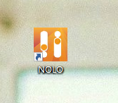Double click to run ，Find the Nolo icon at the tray and right-click to see the device running status.

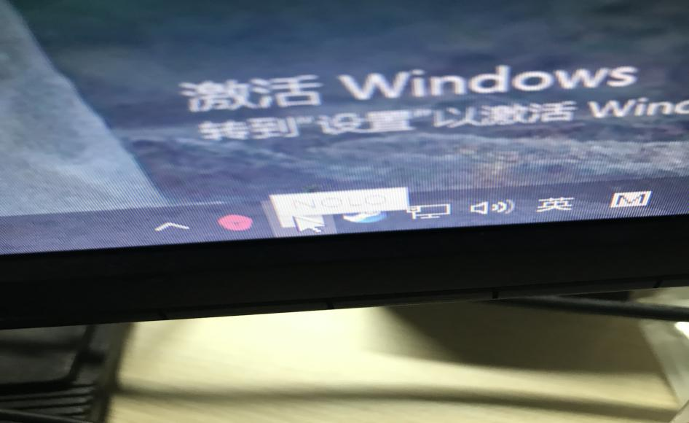

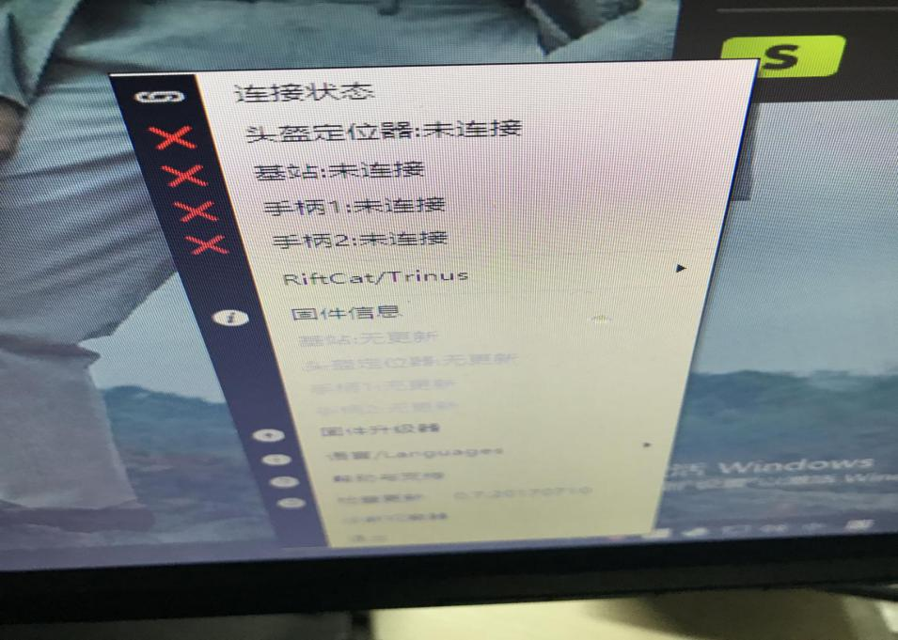

2.Before using the positioning handle, it is recommended that the positioner be secured to the helmet ，And the handle and base station are full of electricity 。

Switch all the switches on until all the lights are green. 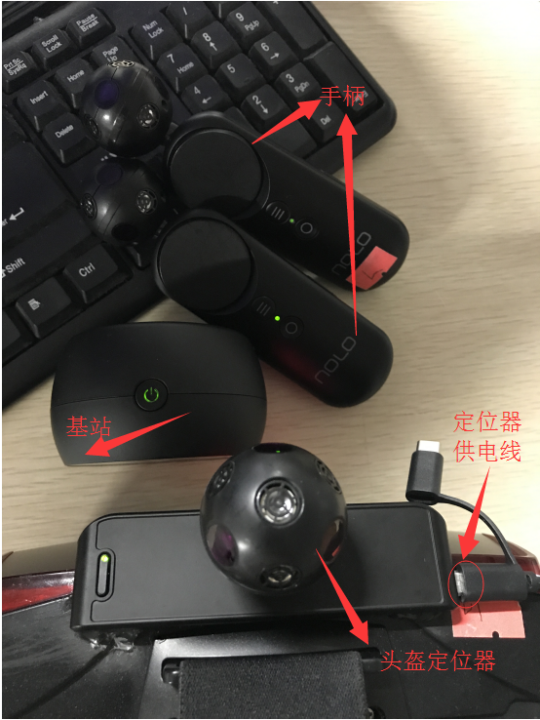

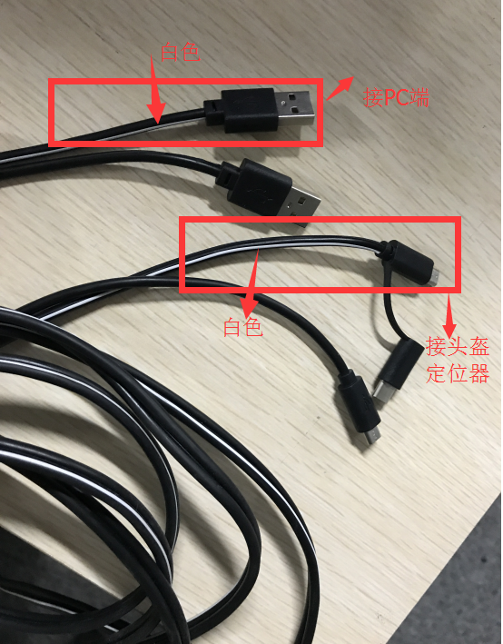

3.Right click to see device connection status and get ready .

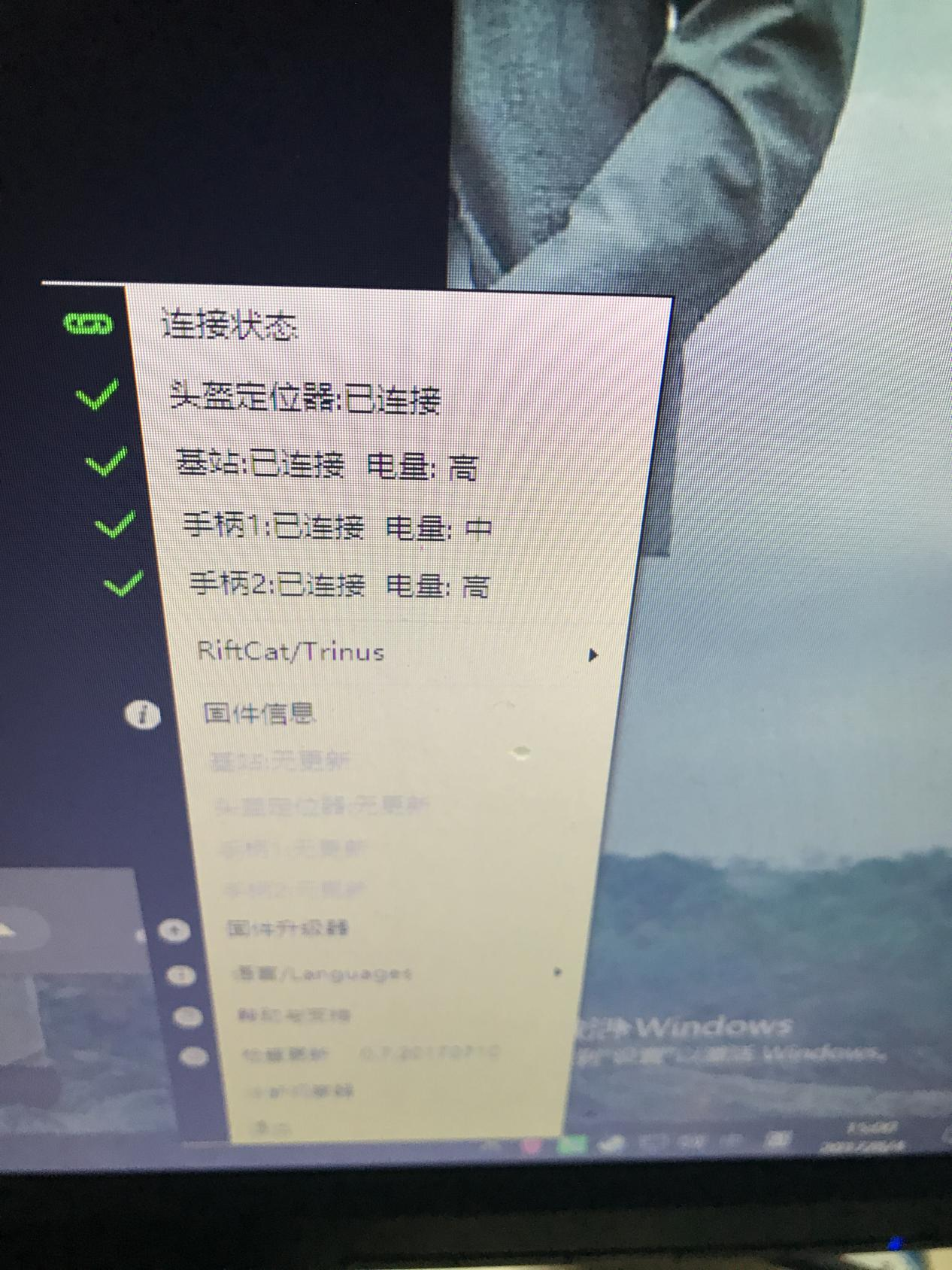

4.Run VRCube and steamVR, see the helmet and handle connection status, show green, that is normal.

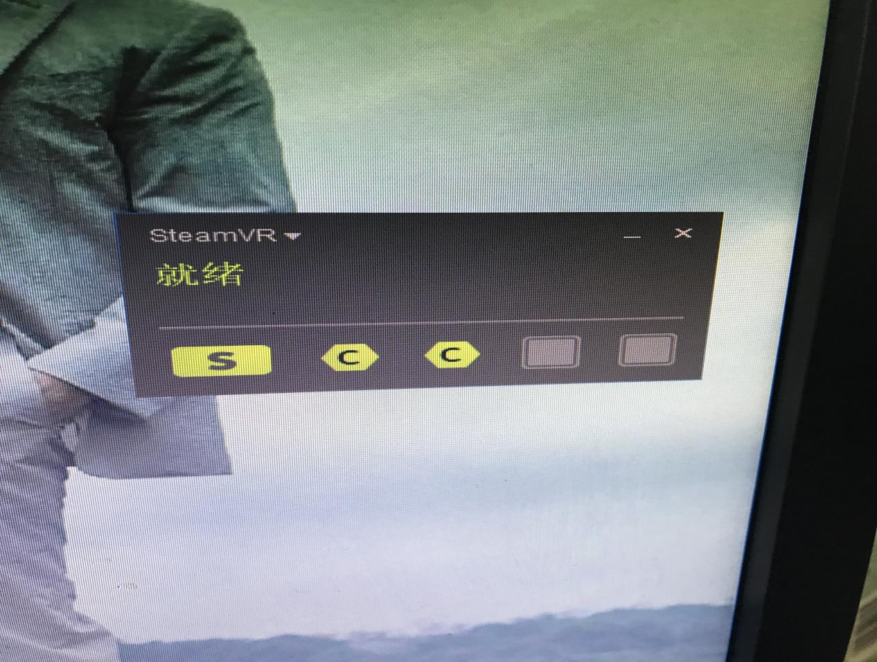

5.Double click the game shortcut, you can run the game. (if the game is not downloaded by the steam platform, double-click the executable file exe)

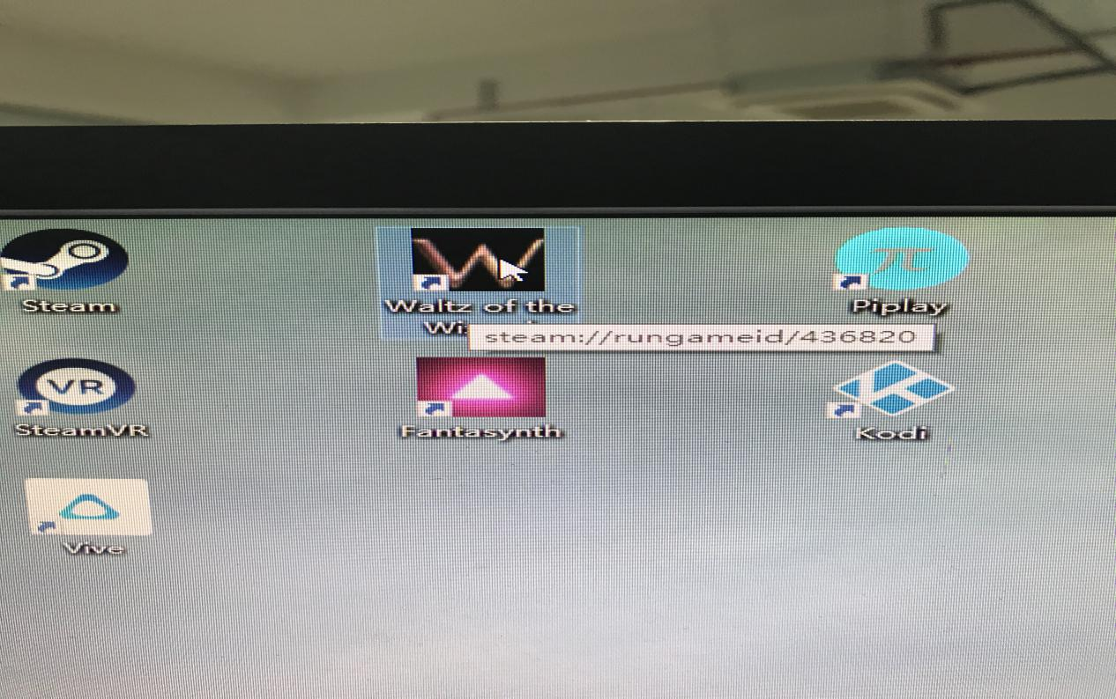

6.The game is running successfully

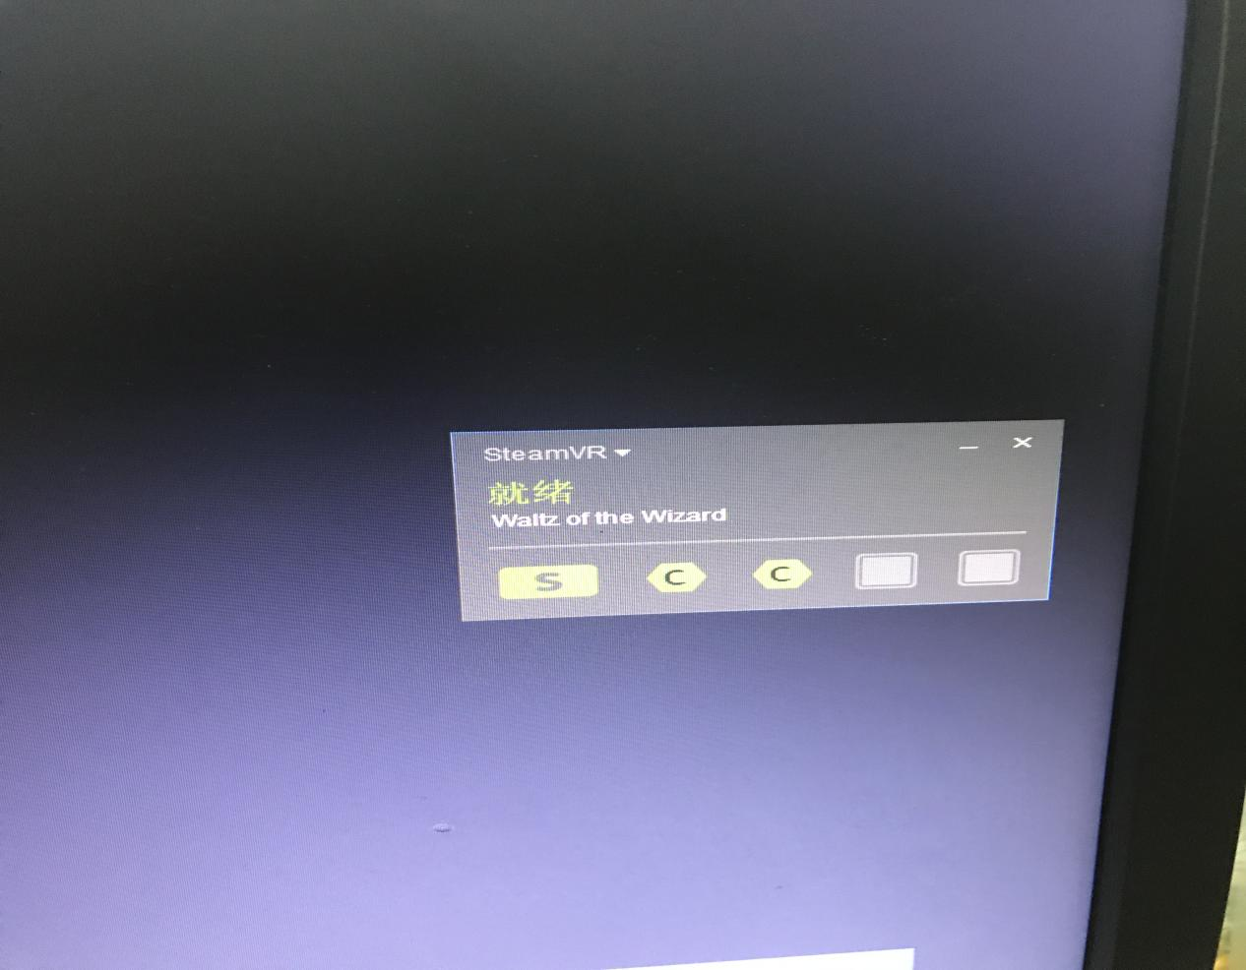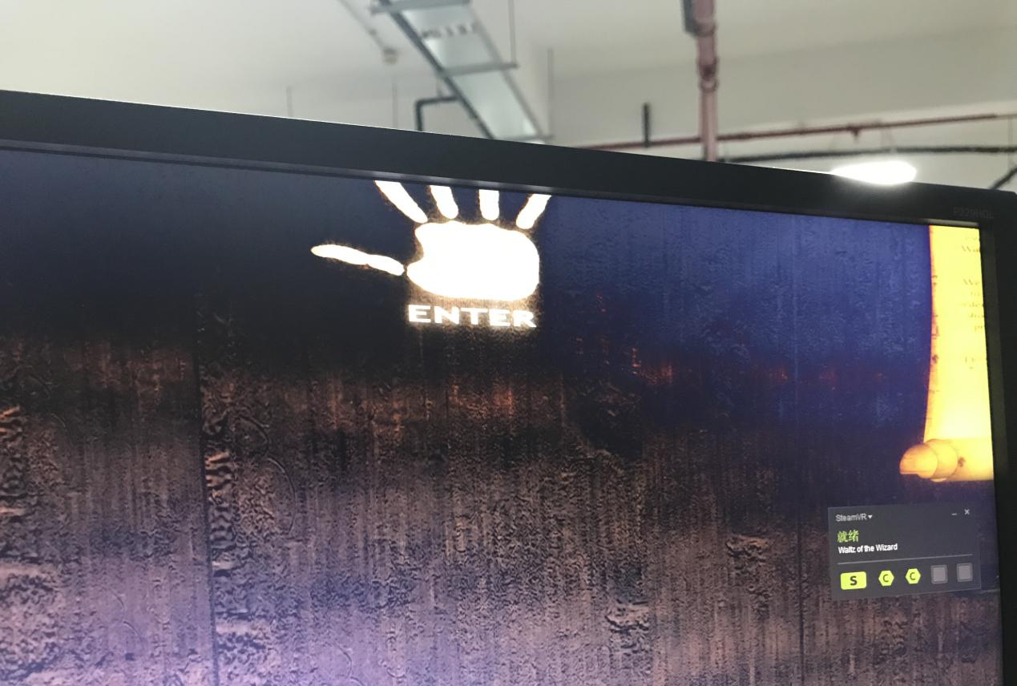

Ps: if the device's indicator light is not green, please re adapt and press the small key behind the base station.

(1) Long press the base station behind the pairing key, and stop the rotation of the base station, then let go.

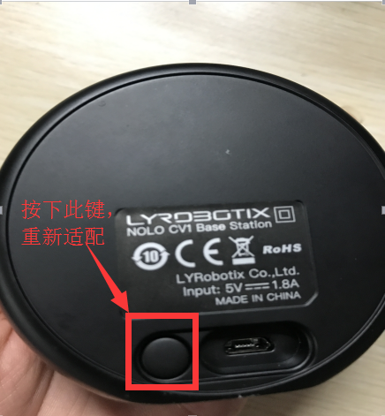

1. A pair of keys (small keys) that are pressed on the side of a handle and released when the handle is shaken and then paired with the other handle in the same way .

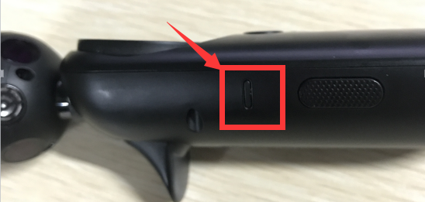

1. Push the button on the helmet positioner, etc., and the lights flash and loosen.

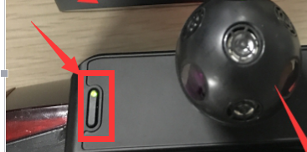

(4) Light the pairing key behind the base station, exit the pairing mode, and complete the pairing

